# 1. Introduction of the CONSOL Mlutiphysics

COMSOL Multiphysics is a cross-platform finite element analysis, solver and multiphysics simulation software. It allows conventional physics-based user interfaces and coupled systems of partial differential equations (PDEs). COMSOL provides an IDE and unified workflow for electrical, mechanical, fluid, and chemical applications. An API for Java and LiveLink for MATLAB may be used to control the software externally, and the same API is also used via the Method Editor.

In lab-1, we used Heat Transfer model to model multiple components on an circuit board and apply electrical excitation and analyze the thermal distribution. According to the result, we can realise the effect of different power, voltage, position of the chip and the width of any elements on the chip temperature.

# Task2 introduction

In task2, we follow the “Introduction to the Heat Transfer module” to add thermal contact and use it to compare that effect of the component surface temperature. Apply the thin layer feature as explained in the lecture-3 to the three IC components base attachment to the FR4 board. Input gap conductance is:

1/area of the contact *3.1[degC/W]

Each side length is 10mm, so the area of the contact is 100mm2.

Tips:(During the experiments, the conductance we calculated was not make sense because It is double the material with the best conductivity. Finally, we used the copper conductance which is 384 in our lab.)

# Task2 result

**The surface temperature indifferent powers:**

|  |  |  |
| --- | --- | --- |
| **Input power** | **Temperature**  **(with thermal contact)** | **Temperature (without thermal contact)** |
| **0.2** | **433.26** | **433.28** |
| **0.3** | **433.38** | **433.40** |
| **0.4** | **433.49** | **433.50** |
| **0.5** | **433.59** | **433.61** |
| **0.6** | **433.70** | **433.71** |
| **0.7** | **433.80** | **433.81** |
| **0.8** | **451.32** | **451.34** |
| **0.9** | **469.36** | **469.38** |
| **1** | **487.27** | **487.29** |

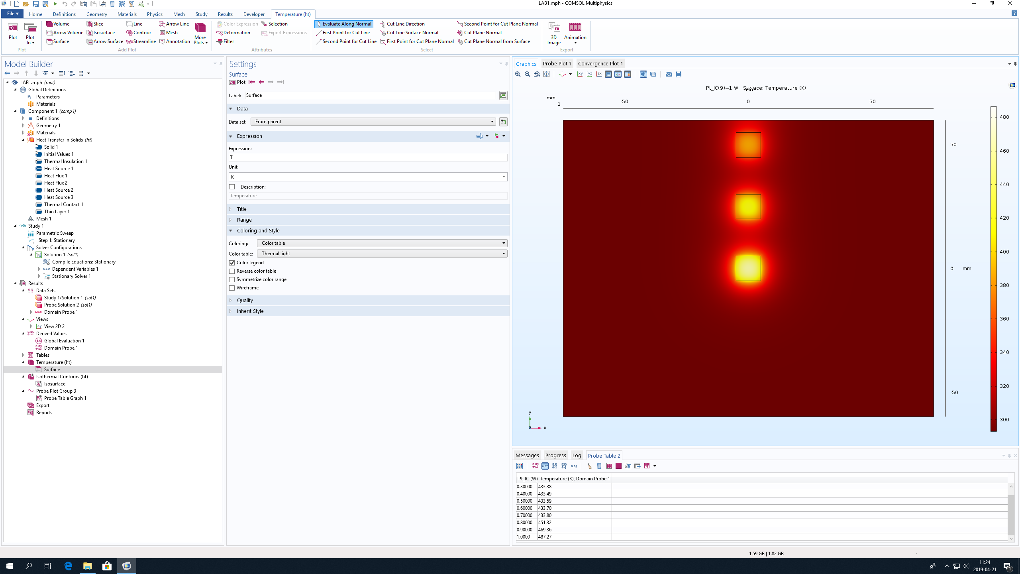

According to the data we got, the thermal contact is not effect the surface temperature so much. The temperature variation is proportional to the power input. The maximum temperature is 487.27℃ on 1w and the minimum temperature is 433.26 on 0.2w. The variation of the temperature is around 0.01~0.02, It is small enough to be ignored.